|  |  |
| --- | --- |
| EGC_Black | Student Name \_\_\_\_\_\_\_\_\_\_\_\_\_\_\_\_\_\_\_\_\_\_\_    **Eastern Goldfields College**  Mathematics 2015  Test 5 (U2 T2) – Calculator Free1 |
|  | **Total Marks: 25 marks** |

**Time allowed: 25 minutes**

**No calculator or notes permitted for this section.**

***Answer all of the following questions. Show all working to obtain full marks.***

**Question 1** **(5 marks: 1, 2, 2)**

State the **gradient** and the co-ordinates of the **y intercept** of each of the following straight lines.











$y=4-5x$

$3y=6x-2$

$2x+3y=12$

**Question 2** **(6 marks: 2, 2, 2)**



1. State the equations of the lines in the graph shown below.

A: \_\_\_\_\_\_\_\_\_\_\_\_\_\_\_\_

B: \_\_\_\_\_\_\_\_\_\_\_\_\_\_\_\_

1. Draw the line $y= \frac{2}{3}x-4$

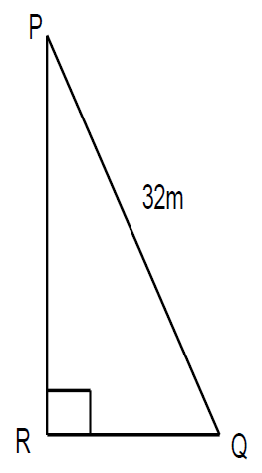**Question 3** **(3 marks)**

Consider triangle *PQR* where 𝑐𝑜𝑠 ∠ 𝑄𝑃𝑅 = $\frac{5}{8}$ and   
side *PQ* has length 32 m.

Determine the length of side *PR*.

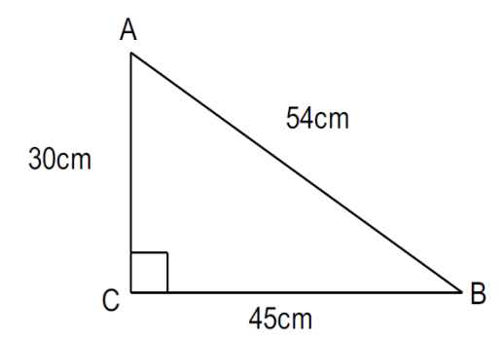**Question 4**  **(2 marks: 1, 1)**

Consider the triangle *ABC*.

a) Determine the value of 𝑠𝑖𝑛 ∠ 𝐵𝐴𝐶.

b) If the lengths of the sides of the triangle were all doubled in size, how would this effect the value of 𝑠𝑖𝑛∠ 𝐵𝐴𝐶?

**Question 5** **(4 marks: 2, 2)**

In the diagram below, Point **B** is at a true bearing of 075o from point **A**.

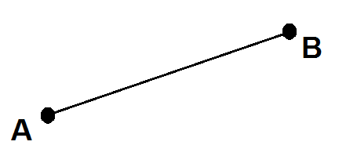

1. What is the compass bearing from A to B? \_\_\_\_\_\_\_\_\_\_\_\_\_\_\_
2. What is the true bearing to A from B? \_\_\_\_\_\_\_\_\_\_\_\_\_\_\_

**Question 6** **(5 marks: 2, 3)**

Harry was 15m due south of Zayn. Liam is due east of Harry and on a bearing of 158° from Zayn.

1. Draw a diagram to represent the above information.
2. Calculate the distance between Harry and Liam. An approximation of *tan22 = 0.4.*

**End of Non-Calculator Section**

|  |  |
| --- | --- |
| EGC_Black | Student Name \_\_\_\_\_\_\_\_\_\_\_\_\_\_\_\_\_\_\_\_\_\_\_    **Eastern Goldfields College**  Mathematics Applications 2015  Test 5 (U2 T2) – Calculator Assumed1 |
|  | **Total Marks: 37 marks** |

**Time allowed: 38 minutes**

**Calculator and 1 x double sided A4 notes permitted for this section.**

***Answer all of the following questions. Show all working to obtain full marks.***

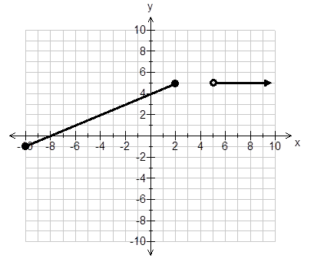**Question 1** **(9 marks: 2, 3, 4)**

Consider the piecewise function shown.

1. For what values of 𝑥 is 𝑦 = 5?
2. What is the gradient of each   
   section of this graph?
3. Write functions to define the graph   
   shown.

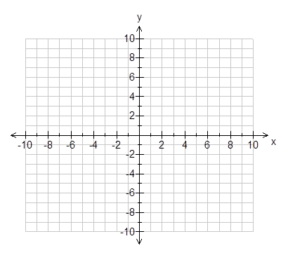

**Question 2** **(5 marks: 3, 2)**

Graph the following functions on the

axes below



$4x+5y= -10; -10<x<5$

$x=10; y≥-5$

**Question 3** **(8 marks: 2, 2, 4)**

Calculate the value of the unknown side or angle in each of the following right-angled

triangles. Round your answers to 1 decimal place.

1. 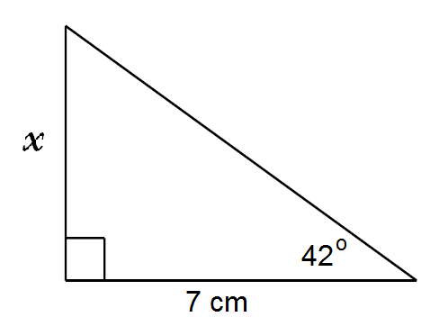

1. 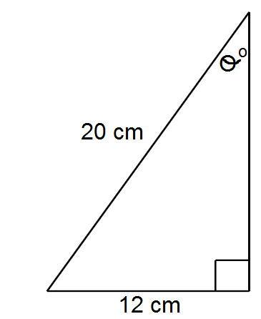
2. 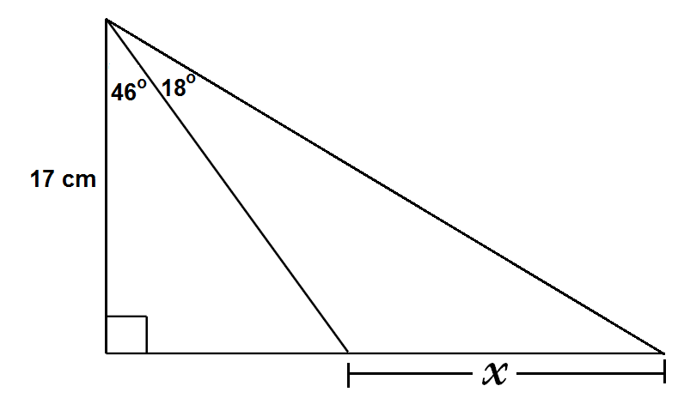

**Question 4** **(7 marks: 1, 2, 1, 3)**

A children’s slide at the park can have a maximum angle of elevation of 31 degrees according to council regulations. Round your answers to 1 decimal place.

A 2.5m slide is erected in a park with the maximum slope.

a) Draw a diagram of this slide.

b) Determine the height of the slide.

The playground engineer wants to make a second slide. He wants it to be 1.3m high and 2.2m long.

1. Draw a diagram of this slide.

d) Does this second slide pass council regulations? Justify.

**Question 5** **(8 marks: 6, 2)**

Cecelia goes into the city to visit her friend Marcia for coffee. She rides her bike for 12 mins to the train station which is 2km away. She had to wait 6 mins for the train to arrive. It was an 18 min and 21km train ride to the city. Cecelia then took 6 mins to walk 500m to the café where she met Marica for coffee. The pair enjoyed coffee and cake for an hour and then Marcia drove Cecelia back to where she left her bike in 12 mins. Finally Cecelia then rode her bike for 12 mins home.

1. Complete the travel graph below.

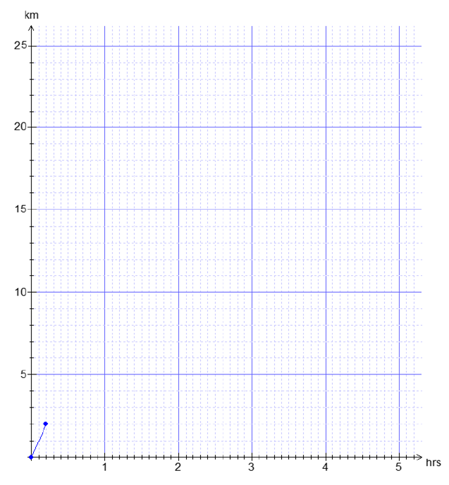

hrs

1. If Cecelia left her home at 10 am, what time did she return home after meeting Marcia?

**End of Calculator Section**